Field of Dreams? Try Miracle (Part 1)
posted by bwgordon on Mon, 04/08/2013 - 11:12

By Alex Cantatore, Turlock Journal Staff Writer

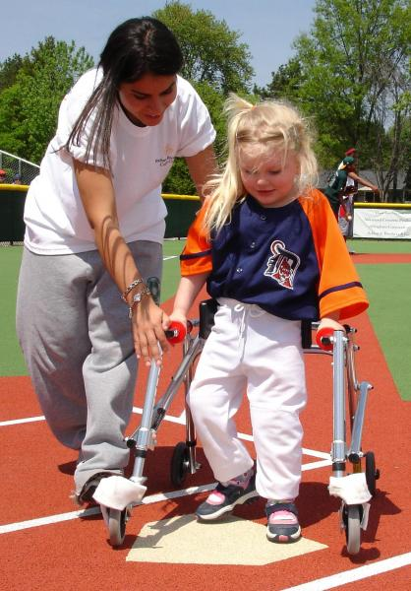
About a year and a half ago, Terry Battcher was forced to pack up his family and move from Visalia to Turlock to follow his job. While the distance between the two towns may not be great, to say Battcher wasn't exactly excited about the move would be an understatement.
"It was against my wanting to move here," said Battcher. "I didn't know why, but I knew God put me here for a reason."
The Battchers were leaving a lot behind in Visalia through the move. The family had a vibrant church life, friends and family, and, perhaps most importantly, a baseball field.
But perhaps we should back up a bit.
Battcher has two children, an able-bodied daughter, and a son who was born with several disabilities including hydrocephalus, cerebral palsy, and a non-verbal learning disorder. Throughout the course of his youth, Battcher's son was in and out of doctors' offices and facilities that tried to help him with his disabilities.
"God had a big part in (me living in Visalia)," Battcher said. "My son required a lot of physical therapy for his cerebral palsy, and one therapist put us in touch with the Miracle League."
The Miracle League is based, quite literally, on a field of dreams.
In the year 1998 in Conyers, Ga., a seven-year old in a wheelchair started watching his little brother play Little League. And he simply loved what he saw.
Why couldn't he and other physically and mentally disabled children play baseball, he wondered. And with that, the ball got rolling.
In 2000, the first Miracle League field opened thanks to funds from the local Rotary and McDonalds. It featured a fully rubberized, cushioned baseball field, where wheelchairs and walkers were created equal and could participate in America's pastime.
The field is flat and smooth, with nowhere to trip. A trip from home plate to center field covers just 125 feet in a compact layout that is easy to travel.
Every player bats once per inning with a soft bat and a soft ball, with the help of their able-bodied buddy. And all players are guaranteed safe on the bases.
Each player scores a run before the inning is over, with the last one up guaranteed a homerun.
And, perhaps most importantly, each team and every player wins every game. Because for these kids, even making it to the field is a victory.
"It's a place where kids with disabilities can just be kids with different abilities," said Battcher. "It's a place where everyone can play."
Before leaving Visalia, Battcher and his son had played side-by-side as a part of the Miracle League. After a year spent in Turlock, he found the Miracle League to be the thing he missed the most about Visalia.
So he decided to do something. In December, Battcher started the Miracle League of Northern San Joaquin Valley and began to form a six-member steering committee.
Last Tuesday, he presented the concept to the Turlock City Council at the bequest of Councilman Ted Howze, in hopes of changing the organization's title to the Miracle League of Turlock.
Howze is very involved with Turlock youth sports, while his wife is an adaptive physical education teacher. As such, the idea of a Turlock Miracle League is very much in keeping with his family's interests.
"This project strikes you to the core," Howze said. "It's of importance to whole community."
An estimated 7,000 children in Stanislaus County could take advantage of such a facility. Thousands more have the opportunity to get involved through the buddy program.
Interest in Miracle Leagues is cropping up all around the nation. Since the founding of the first field in 2000, more than 100 fields have been built nationwide, with hundreds more in the planning stages.
Oakland, Visalia, and San Diego already have fields, with Fresno and Orange County currently developing their own leagues.
These cities have already seen tremendous benefit from their fields, including community recognition, opportunities for high school ballplayers to get involved with youth, and fundraising opportunities such as a USA Womens' Softball visit to Visalia that drew 48,000 people and raised $100,000.
Of course, to get to that point, the field must first be built, and that takes money.
"It will probably cost $750,000 to $1,000,000," said Battcher. "We haven't done budgets, but just knowing what other facilities have taken to build and what our visions for the facility have been like, we don't want to compromise."
The Miracle League is very optimistic that they'll be able to raise all of the money to build the field on their own, thanks to the overwhelming positive response they've received from the community. But, first, they need land to build on.
The City of Turlock is in the preliminary stages of examining whether they may have land to donate to the Miracle League. After Tuesday's council meeting, the matter was referred to the Parks and Recreation Committee for further review.
Battcher says that Modesto and Ceres have also shown some interest, and he has been contacting local churches that may have available land.
"Originally, one of our long-term goals was to have a site this year," said Battcher. "That's probably going to happen faster than I dreamed."
Should all go as planned, the Miracle League hopes to hold its opening pitch sometime in 2011. But the last pitch?
"This facility that I'm dreaming of and wanting to build will be here for a long, long time," Battcher said.
Perhaps, says Battcher, Stanislaus County may one day be home to multiple fields, catering to all of the disabled children in the area and becoming a mecca of community service.
His son, fortunately, has improved from his baseball-playing days, and is now ambulatory and communicating at a level years ahead of his age. And, though Battcher's son will never recover from his ailments, it's not for his son that he wants to build the facility.
"It's for his little sister," he said. "An able bodied girl, who I want to grow up in a community helping others."
Community service is contagious, Battcher says. And once you try being a part of the Miracle League, you're hooked for life.
"I can't tell you what an addiction would be like, but it's like an addiction. It's perfect little athletes that just perfect their sport. It's hard to put into words."

